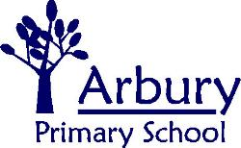
Carlton Way, Cambridge, CB4 2DE

School Telephone: 01223 359568
Email: office@arbury.cambs.sch.uk

Headteacher: Ben Tull

Pupil Premium Funding – We Need Your Help

Dear Parents / Carers of children starting Arbury Primary School,

Attached is a copy of the ‘Application for Free School Meals / Pupil Premium Funding.’ Please fill it in and send it back to school if you think that there is a chance that you might qualify.

Qualifying for a free school meal at any point, means that your children will get pupil premium funding for the next 6 years.

At Arbury, all children who have the pupil premium funding are entitled to:

- Free school trips (No voluntary contribution)
- Extra help with their learning
- Reduced price breakfast club

The money has also helped us to make sure that we have lots of teaching assistants in class, parenting support for families, counselling for children who need it, targeted speech therapy in KS1 and iPads in every classroom.

All children now get a free school meal in EYFS/ KS1, but your child will only get pupil premium funding if you fill in this form.

Our message is to ask you to fill in the form if you are in any doubt because doing so will give the school a better chance of getting the funding that it deserves.

Thank you in advance of your support,

Yours

Ben Tull
Headteacher

