
Strategies for supporting bi lingual learners-

New To English at Arbury Primary School


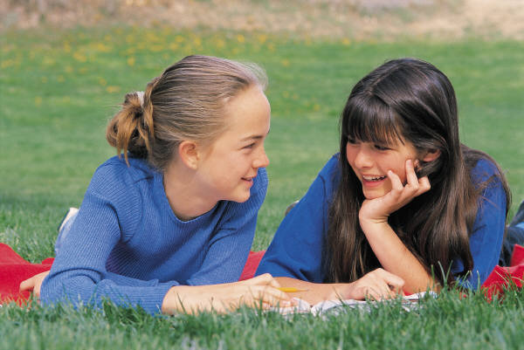

- keep lessons real, not abstract, have real things to see and touch
- do pre teaching of key words, sentences or stories
- speed of speech, don’t garble…rephrase in simpler language
- use key visuals and point clearly to the thing you are talking about
- give explicit explanations
- show the ‘finished product’ so children can see where they are aiming at, the bigger picture
- use of body language is vital ie pointing, nodding, smiling
- use an expressive voice
- ask parents/carers to rehearse key words/ concepts/ stories in first language at home
- repetition of words and phrases
- bilingual assistant (where possible) to translate and then bring back to English
- scaffold responses, don’t allow a child to struggle, if needed, mouth answer to them until confident enough to speak
- sit near an adult who can prompt with key words
- encourage celebration of bilingualism in all children; a culture of diversity and respect is essential, to maintain child’s self esteem
- don’t allow a child’s culture/language to be ‘invisible’, make lots of positive references to culture/home background…be interested
- all children must feel they ‘belong’ so classes with an inclusive atmosphere where children feel they can take risks will work best
- flexible/mixed groupings allow positive language role models
- ask staff to set themselves a target for each day: ask a new child a simple question today. … (eg Is it cold outside? Are they new shoes?) At break some EAL children may become isolated especially if new and don’t get a chance to practise their English
- don’t be worried about a ‘silent period’- this is normal
- use feelings fans
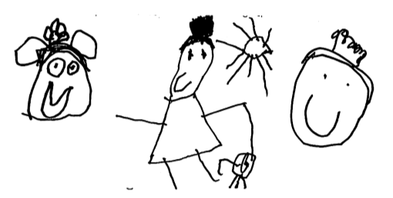
September 2020

