Aims and Values
“Equality, respect and fairness are very important to all of us in our school.”
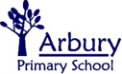

Home/School
Agreement

Teaching and Learning
Our staff work hard to ensure children achieve the highest standards.
Teaching and learning will be carefully planned and fun!
We want our children to be confident learners.
Relationships
We will teach good behaviour by example and the golden Rules.
We will respect each other, including our differences, and show pride in our school.
We will work in partnership with parents/carers.

“In Arbury School we will all enjoy learning in an environment that is secure and stimulating. We will expect the highest standards from our staff and children. All our achievements will be valued and celebrated.”
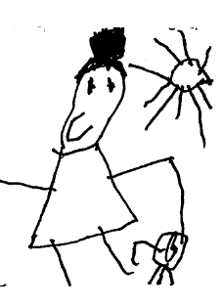

Inside and Outside
We will look after our facilities carefully. We will display work we are proud of. We will be aware of when and how others are working.
We will enjoy our excellent outdoor spaces and use the safely.
We will take care of the trees and wildlife that share them.
Equality
We will give all children opportunity to fulfil their potential, and encourage all children to ‘be themselves’.
We will respect other people’s culture, identity, family, feelings, beliefs and values.
We will respond quickly to any bullying or racist, sexist, homophobic, bi phobic, transphobic or disability related incidents.

Agreement for ________________________________  School agrees to:  - make contact with you when things are going well  - make contact with you if there are any problems with attendance or punctuality  - let you know quickly about any concerns or problems that affect your child’s work or behaviour  - send home an annual report and make your child’s work available for you to see  - prepare and set appropriate work for your child to do with you at home  - arrange regular parent/carer consultations during which progress will be discussed  - keep you informed about school activities through regular newsletters, notices about special events and through the website  - keep you informed about what is going to be taught each half term  - encourage your child to respect the school environment  - encourage your child to treat everybody in the school community with respect and acceptance  - encourage your child to follow the school dress code  - develop your child’s confidence and self-esteem, and instil a love of learning  - work to support children with special educational needs and disabilities |  | Parent/carers  I/we agree to:  - see that my child goes to school regularly, on time, and appropriately dressed  - let school know immediately if my child is going to be absent  - let school know about any concerns or problems that may affect my child’s work or behaviour  - support the school’s policies and guidelines for good behaviour, learning and equality  - encourage my child to follow the Golden Rules  - support my child with learning, including reading with them every day  - attend parent/carer consultations and discussions about my child’s progress  - get to know about my child’s life at the school  - let the school know if someone else will be collecting my child  - avoid taking holidays in school term time  Date: _____________________________  Signed: _____________________________ (Parent/carer)  Signed: _____________________________ (Head teacher)

